**Defect – 1: Created tags are not retrieved correctly**

Steps:

1. Created new Article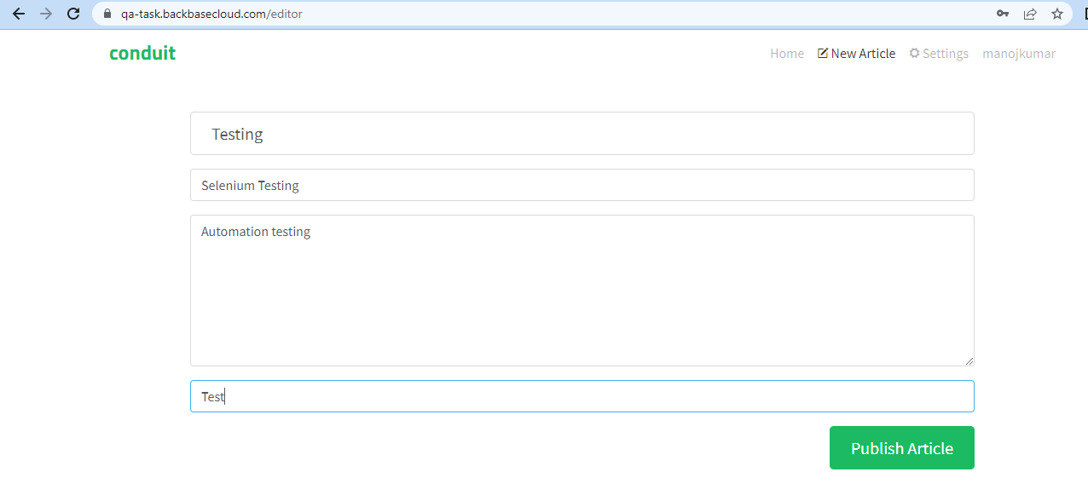
2. Article CreatedGraphical user interface, text, application, website

   Description automatically generated
3. Click Edit ArticleGraphical user interface, text, application, email

   Description automatically generated

**Defect – 2: Created Article is not available in Your Feed page**

Steps:

1. Created Article is available in Global feed PageGraphical user interface, text, application, Word

   Description automatically generated
2. Available in My posts pageGraphical user interface, application

   Description automatically generated
3. Not Available in Your Feed PageGraphical user interface, application, Word

   Description automatically generated

**Defect – 3: Favourited Posts are displayed in Favourited Posts page**

Steps:

1. Click the Favourite Article in Global FeedGraphical user interface, application

   Description automatically generatedGraphical user interface, text, application

   Description automatically generated
2. Liked posts are not available in favourited posts page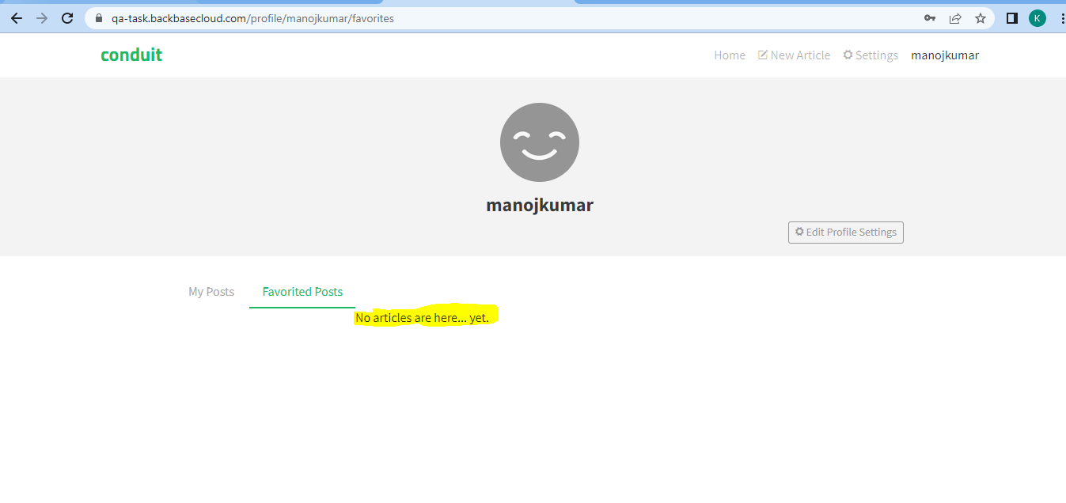

**Defect – 4: Added comment is not visible when opening the article from Global Feed/My Posts**

Step 1: Add comment to Article

